**CHAPTER 4**

**SYSTEM ANALYSIS**

**4.1 INTRODUCTION**

**System Analysis** is a process of collecting and interpreting facts, identifying the problems, and decomposition of a system into its components. It is conducted for the purpose of studying a system in order to identify its objectives. It is a problem solving technique that improves the system and ensures that all the components of the system work efficiently to accomplish their purpose.

**4.2 Unified Modeling Language (UML) DIAGRAMS**

The UML contains different diagrams for system analysis and modeling. In this project use case diagram are used to identify the relationship between the different users.

**4.2.1 USE CASE DIAGRAM**

Use case diagram describes the behavior of the target system from an external point of view.

* **Use cases**. A use case describes a sequence of actions that provide something of measurable value to an actor and is drawn as a horizontal ellipse.
* **Actors**. An actor is a person, organization, or external system that plays a role in one or more interactions with your system. Actors are drawn as stick figures.
* **Associations**.  Associations between actors and use cases are indicated by solid lines. An association exists whenever an actor is involved with an interaction described by a use case.

**Figure 4.1 Use Case Diagram for UNLEASH YOUR STRENGTH**

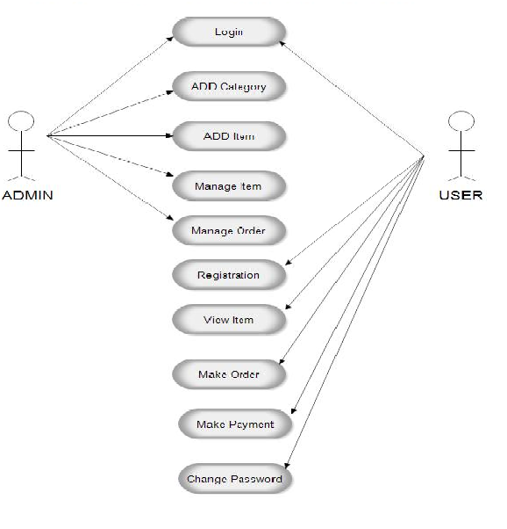

**CHAPTER 5**

**SYSTEM DESIGN**

**5.1 INTRODUCTION**

The **"Unleash Your Strength"** website system has been meticulously designed as an official platform for students to purchase gym products and interact with fitness experts to gain knowledge. After thorough analysis and refinement, the system has progressed to the design stage, focusing on the essential components necessary for the smooth operation of the website.

**5.2 USER INTERFACE DESIGN**

The user interface of the **"Unleash Your Strength"** website is designed to be intuitive and user-friendly, catering to the diverse needs of users accessing the platform.

**5.2.1 STATIC PAGES**

Static web pages, which are delivered to users exactly as stored, play a crucial role in providing consistent information to users. These pages, typically HTML documents, form the backbone of the website and are accessible via HTTP. The static pages utilized in the website include:

* Home Page
* Products Catalog
* Testimonials
* About Us
* Contact Us
* Shopping Cart

A sample design of the static pages is provided below:

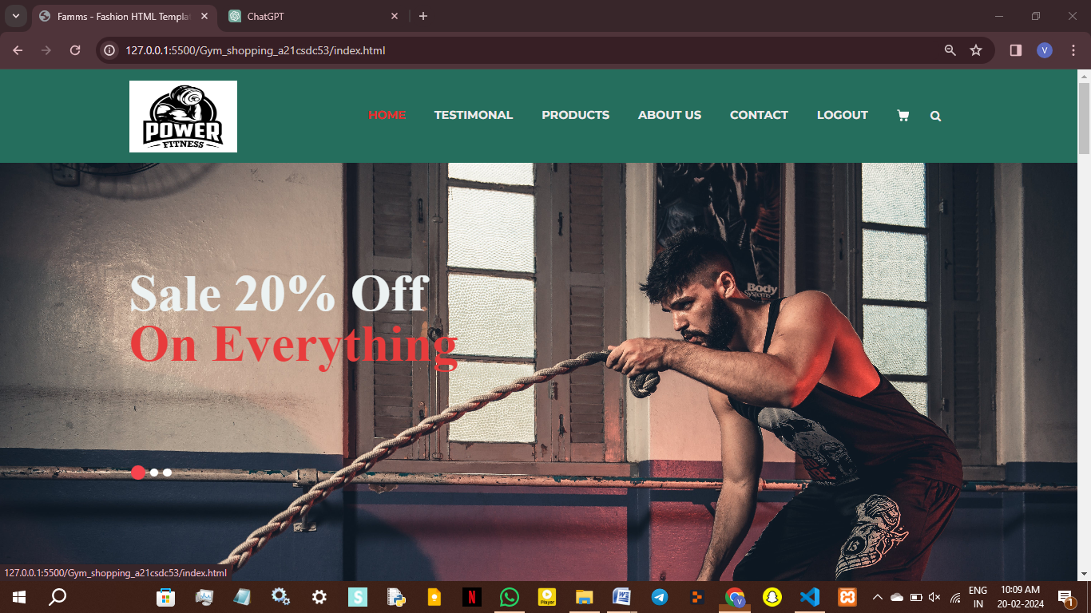

5.2.2 DYNAMIC PAGES

Dynamic web pages, on the other hand, display different content based on various factors such as time of day, user interaction, or user profile. These pages enhance user engagement and provide personalized experiences. The dynamic pages incorporated into the website are grouped under three main categories:

* User Account Dashboard
* Product Recommendations
* Expert Consultation Interface

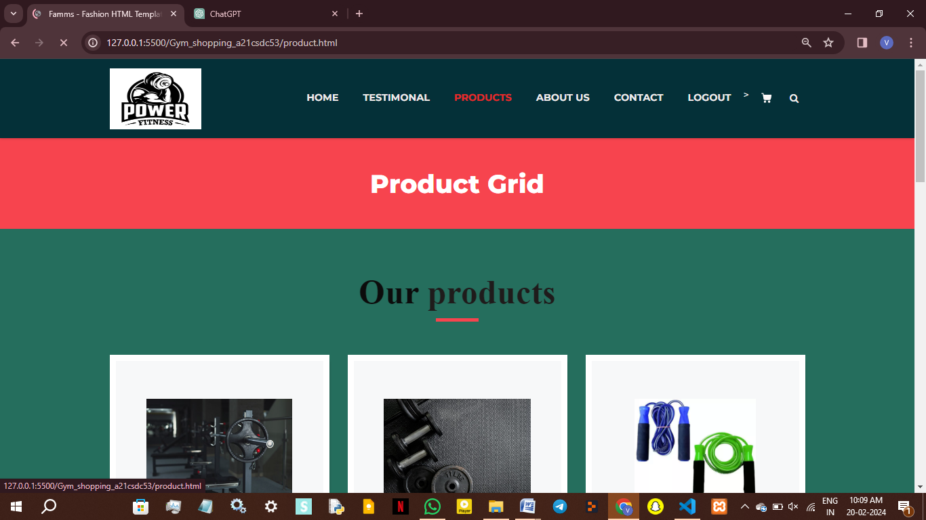

**5.3 DATABASE SIGN IN**

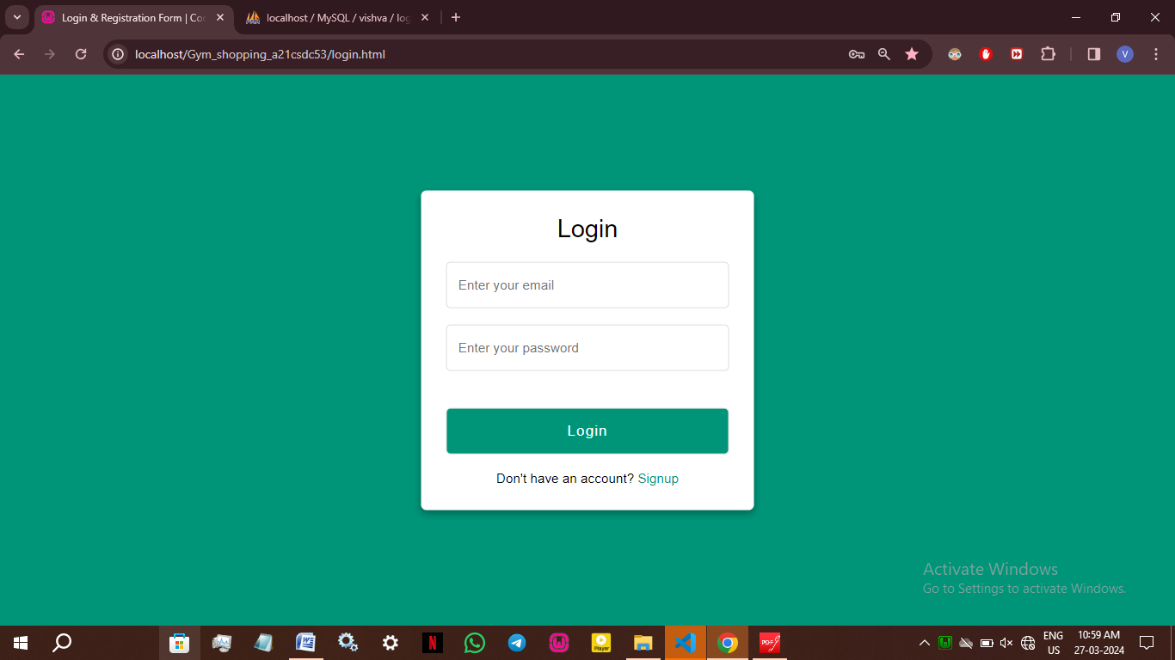

**5.3.1 DATABASE CONNECTION**

The database schema for the "Unleash Your Strength" website consists of several tables to store essential information related to users, products, and feedback. The tables created include:

**5.3.1.1 DATABASE NAME: USERS**

**TABLE NAME: ACCOUNTS**

**Fields:**

USER_ID (INT), USERNAME (VARCHAR), PASSWORD (VARCHAR),

**5.3.1.2 DATABASE NAME: VISHVA**

**TABLE NAME: LOGIN**

**Fields:**

USERNAME (VARCHAR), EMAIL(VARCHAR), PASSWORD (VARCHAR),

The database design implemented ensures the efficient storage and retrieval of data, thereby facilitating seamless functionality of the website. By structuring the database in a logical and optimized manner, it enables swift access to information, contributing to a responsive user experience. With considerations for scalability and performance, the design accommodates the growth of data volume and user interactions without compromising system responsiveness. Through effective indexing, normalization, and appropriate data structures, the database setup promotes efficient querying and data manipulation, supporting the website's functionalities with reliability and agility. This thoughtful approach to database design enhances the overall performance and usability of the website, ensuring a smooth and satisfying user experience.